A Physics Evoked Meshfree Method
MA Zhi-bo¹ ZHAO Ya-zhou²(Phd Candidate)
- Institute of Applied Physics and Computational Mathematics, Beijing 100094, China；
2. Institute of Geology and Geophysics, Chinese Academy of Science, Beijing 100029, China)
asiabuaasa@163.com
Abstract: In mesh free methods, discrete equations are built according to physics information of micro-bodies arbitrarily spread in vicinal space. As the requirements about topology of micro-bodies are reduced, simulations with Lagrangian approach may be easier even with large distortions. Owing to the insufficiency of topological information, there is a challenge for mesh-free method to reflect physics especially as discontinuities exist. Based on the physical laws and developing trend of numerical simulation, a new mesh free systematic method PECM (Physics Evoked Cloud Method) which has excellent applicability is shown. High fidelity to physics of the method is demonstrated through five 1-dimentional challenging problems in which strong discontinuities exist.
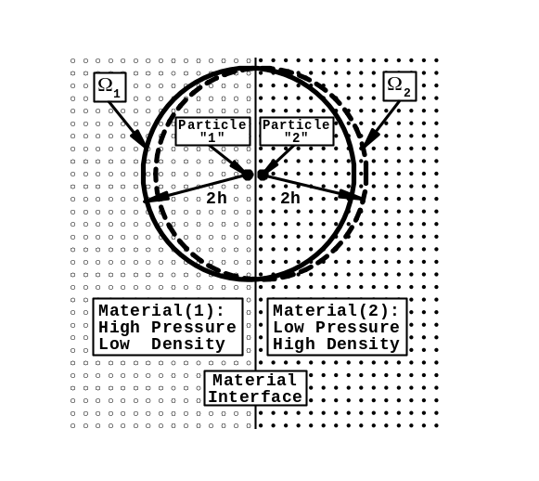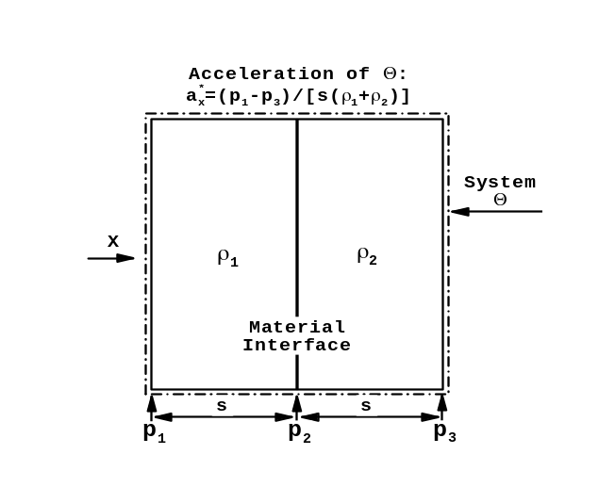
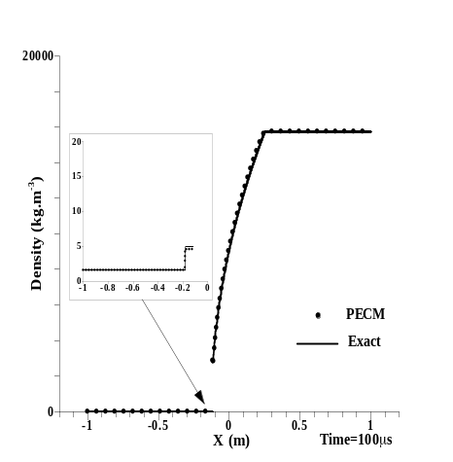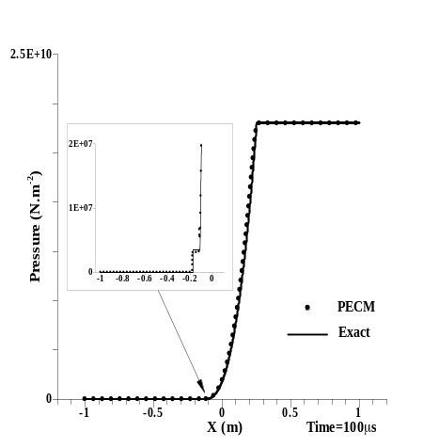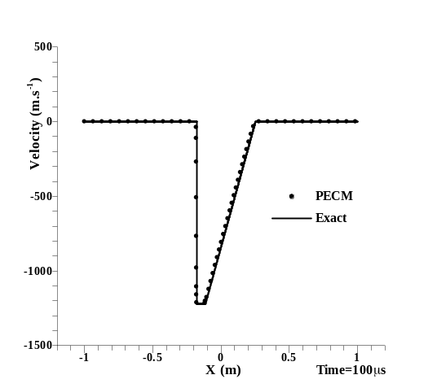
Fig. 1 Kernel Modification in PECM (top)&Validation of PECM(down): Numerical results about Case5
Referrence：
[1] Gingold R A and Monaghan J J. Kernel estimates as a basis for general particle methods in hydrodynamics [J]. Journal of Computational Physics, 1982, 46(3): 429-453.
[2] Sigalotti L D G, López H et al. A shock-capturing SPH scheme based on adaptive kernel estimation [J]. Journal of Computational Physics, 2006, 212(1): 124-149.
Relevant Workshop Topics as follow:
1.Computational Modelling using SPH; 2.Theoretical and Numerical Aspects of SPH;
3.SPH Applications

